Spherical Segment
# Source: AI Source: Provided by: [Data Path: Persons Table -> ID Column: 1, Name_En Column: Motasem Essam] -> From: [ChatGPT] on [7/25/2026]
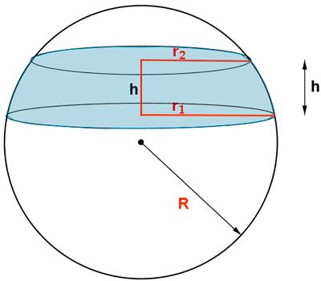
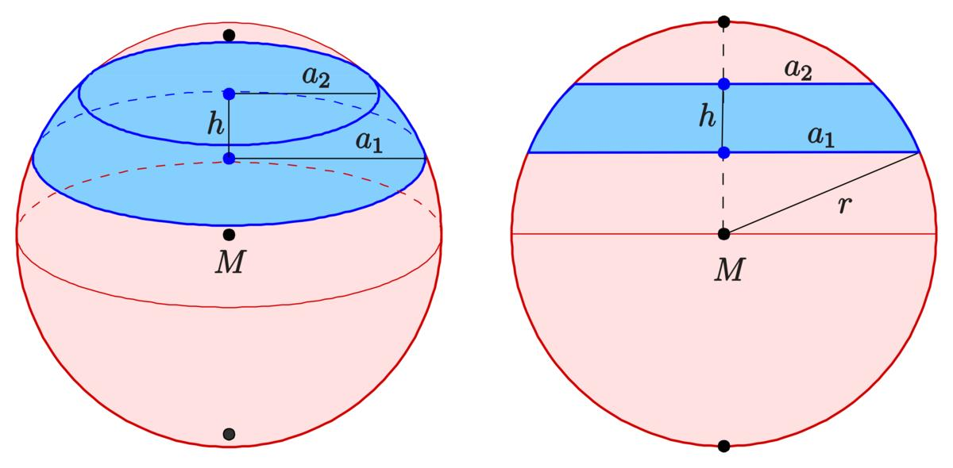
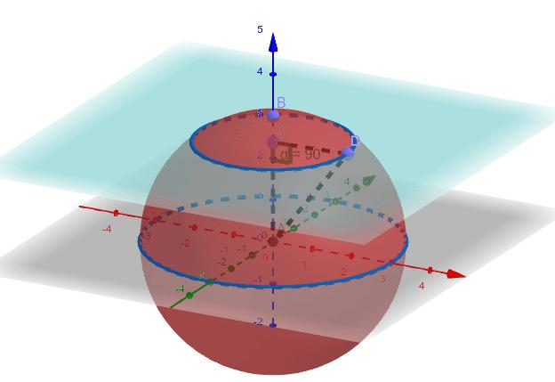

Definition
# Source: AI Source: Provided by: [Data Path: Persons Table -> ID Column: 1, Name_En Column: Motasem Essam] -> From: [ChatGPT] on [7/25/2026]
A spherical segment is the portion of a solid sphere enclosed between two parallel planes that cut through the sphere. It has a curved spherical surface and usually two circular bases.
The two cutting planes may be at different distances from the sphere's center, so the two circular bases may have different radii.

Simple Definition
# Source: AI Source: Provided by: [Data Path: Persons Table -> ID Column: 1, Name_En Column: Motasem Essam] -> From: [ChatGPT] on [7/25/2026]
A spherical segment is the solid part of a sphere between two parallel flat cuts.
When the cutting planes are at different heights, the segment usually has two circular bases of different sizes.

Types of Spherical Segments
# Source: AI Source: Provided by: [Data Path: Persons Table -> ID Column: 1, Name_En Column: Motasem Essam] -> From: [ChatGPT] on [7/25/2026]
Spherical segments can be classified according to the position of their two cutting planes and the sizes of their bases.

Unequal-Base Spherical Segment
# Source: AI Source: Provided by: [Data Path: Persons Table -> ID Column: 1, Name_En Column: Motasem Essam] -> From: [ChatGPT] on [7/25/2026]
The two cutting planes are at different distances from the sphere's center. The circular bases have different radii.
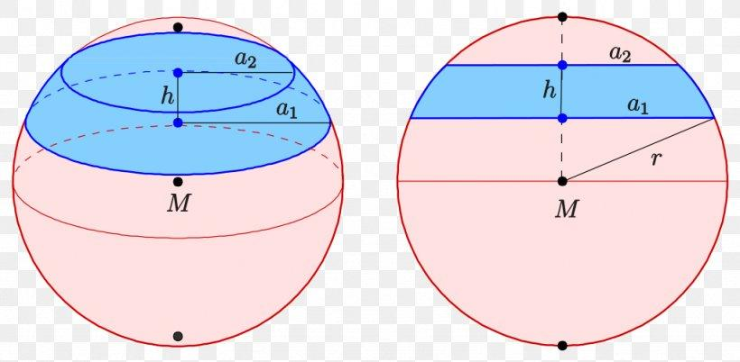

Equal-Base Spherical Segment
# Source: AI Source: Provided by: [Data Path: Persons Table -> ID Column: 1, Name_En Column: Motasem Essam] -> From: [ChatGPT] on [7/25/2026]
The cutting planes are symmetrically positioned on opposite sides of the sphere's center. The two circular bases have equal radii.

Hemispherical Segment
# Source: AI Source: Provided by: [Data Path: Persons Table -> ID Column: 1, Name_En Column: Motasem Essam] -> From: [ChatGPT] on [7/25/2026]
A special case in which one cutting plane passes through the center and the other boundary is the sphere's pole. The resulting solid is a hemisphere, with one flat circular base.
Terminology note: In standard geometry, a spherical segment is most commonly the part of a sphere between two parallel planes. A hemisphere is more precisely a special spherical cap, or half-sphere, rather than a segment with two distinct cutting-plane bases.
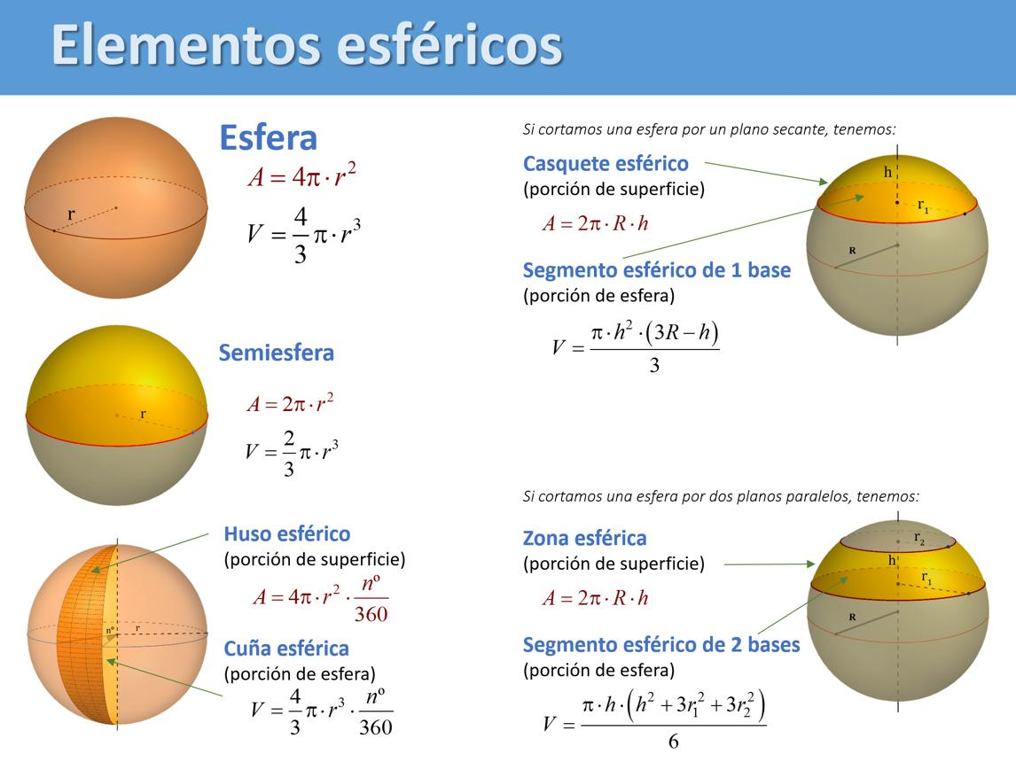

Main Parts and Symbols
# Source: AI Source: Provided by: [Data Path: Persons Table -> ID Column: 1, Name_En Column: Motasem Essam] -> From: [ChatGPT] on [7/25/2026]
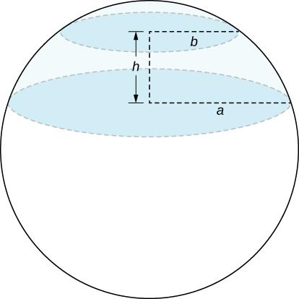
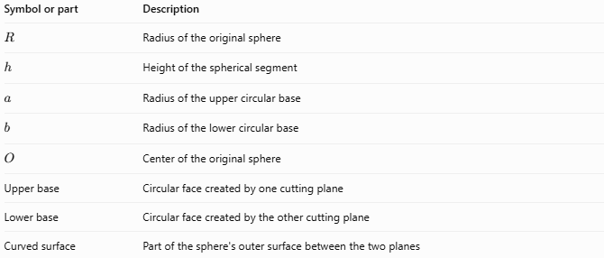
Symbol or part | Description
$$R$$ | Radius of the original sphere
$$h$$ | Height of the spherical segment
$$a$$ | Radius of the upper circular base
$$b$$ | Radius of the lower circular base
$$O$$ | Center of the original sphere
Upper base | Circular face created by one cutting plane
Lower base | Circular face created by the other cutting plane
Curved surface | Part of the sphere's outer surface between the two planes
The segment height $h$ is the perpendicular distance between the two parallel cutting planes.

Mathematical Formulas
# Source: AI Source: Provided by: [Data Path: Persons Table -> ID Column: 1, Name_En Column: Motasem Essam] -> From: [ChatGPT] on [7/25/2026]
For a sphere of radius $R$, let the segment height be $h$, and let the radii of its two bases be $a$ and $b$.

A. Volume of a Spherical Segment
# Source: AI Source: Provided by: [Data Path: Persons Table -> ID Column: 1, Name_En Column: Motasem Essam] -> From: [ChatGPT] on [7/25/2026]
The volume is
$$\boxed{V=\frac{πh}{6}\left(3a^{2}+3b^{2}+h^{2}\right)}$$
This formula calculates the volume of the solid between the two parallel planes.

B. Curved Surface Area
# Source: AI Source: Provided by: [Data Path: Persons Table -> ID Column: 1, Name_En Column: Motasem Essam] -> From: [ChatGPT] on [7/25/2026]
The curved spherical surface area is
$$\boxed{A_{c}=2πRh}$$
Here, $R$ is the radius of the original sphere, not either base radius.

C. Total Surface Area
# Source: AI Source: Provided by: [Data Path: Persons Table -> ID Column: 1, Name_En Column: Motasem Essam] -> From: [ChatGPT] on [7/25/2026]
If both circular bases are included, the total surface area is
$$A_{T}=A_{c}+πa^{2}+πb^{2}$$
Therefore,
$$\boxed{A_{T}=2πRh+π\left(a^{2}+b^{2}\right)}$$

D. Radius of Each Base
# Source: AI Source: Provided by: [Data Path: Persons Table -> ID Column: 1, Name_En Column: Motasem Essam] -> From: [ChatGPT] on [7/25/2026]
If the perpendicular distance from the sphere's center to a cutting plane is $d$, the radius $r$ of the circular cross-section is
$$\boxed{r=\sqrt{R^{2}-d^{2}}}$$
Use the appropriate distance $d$ for each cutting plane to calculate $a$ and $b$.

Worked Examples
# Source: AI Source: Provided by: [Data Path: Persons Table -> ID Column: 1, Name_En Column: Motasem Essam] -> From: [ChatGPT] on [7/25/2026]
Example 1: Finding the Volume
A spherical segment has height $h=4\text{ cm}$, upper base radius $a=3\text{ cm}$, and lower base radius $b=4\text{ cm}$. Find its volume.
Solution
$$V=\frac{πh}{6}\left(3a^{2}+3b^{2}+h^{2}\right)$$
Substitute the values:
$$V=\frac{4π}{6}\left(3\left(3^{2}\right)+3\left(4^{2}\right)+4^{2}\right)$$
$$V=\frac{2π}{3}\left(27+48+16\right)$$
$$V=\frac{2π}{3}\left(91\right)$$
$$\boxed{V=\frac{182π}{3}{\text{ cm}}^{3}}$$
$$V≈190.59{\text{ cm}}^{3}$$
Example 2: Finding the Curved Surface Area
A spherical segment is cut from a sphere of radius $R=10\text{ cm}$. The distance between its cutting planes is $h=5\text{ cm}$.
$$A_{c}=2πRh$$
$$A_{c}=2π\left(10\right)\left(5\right)$$
$$\boxed{A_{c}=100π{\text{ cm}}^{2}≈314.16{\text{ cm}}^{2}}$$
Example 3: Finding the Total Surface Area
A spherical segment has $R=5\text{ cm}$, $h=2\text{ cm}$, and base radii $a=4\text{ cm}$, $b=\sqrt{21}\text{ cm}$.
First, calculate the curved area:
$$A_{c}=2π\left(5\right)\left(2\right)=20π$$
Then add the two base areas:
$$A_{T}=20π+π\left(4^{2}\right)+π{\left(\sqrt{21}\right)}^{2}$$
$$A_{T}=20π+16π+21π$$
$$\boxed{A_{T}=57π{\text{ cm}}^{2}≈179.07{\text{ cm}}^{2}}$$

Comparison with Related Geometric Shapes
# Source: AI Source: Provided by: [Data Path: Persons Table -> ID Column: 1, Name_En Column: Motasem Essam] -> From: [ChatGPT] on [7/25/2026]
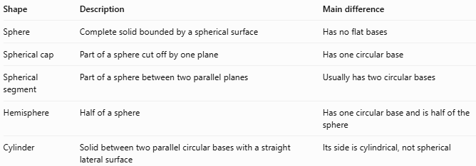
Shape | Description | Main difference
Sphere | Complete solid bounded by a spherical surface | Has no flat bases
Spherical cap | Part of a sphere cut off by one plane | Has one circular base
Spherical segment | Part of a sphere between two parallel planes | Usually has two circular bases
Hemisphere | Half of a sphere | Has one circular base and is half of the sphere
Cylinder | Solid between two parallel circular bases with a straight lateral surface | Its side is cylindrical, not spherical

Applications
# Source: AI Source: Provided by: [Data Path: Persons Table -> ID Column: 1, Name_En Column: Motasem Essam] -> From: [ChatGPT] on [7/25/2026]
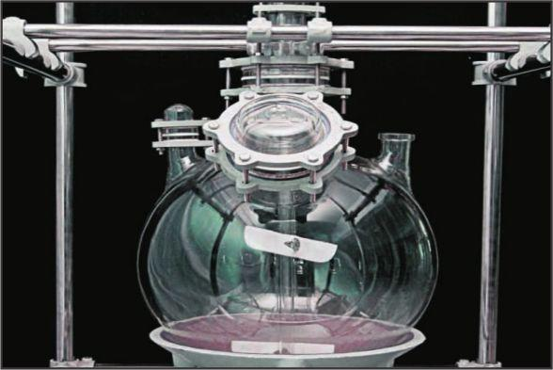
Engineering and Manufacturing
Used to calculate the volume and surface area of spherical components cut by parallel planes.
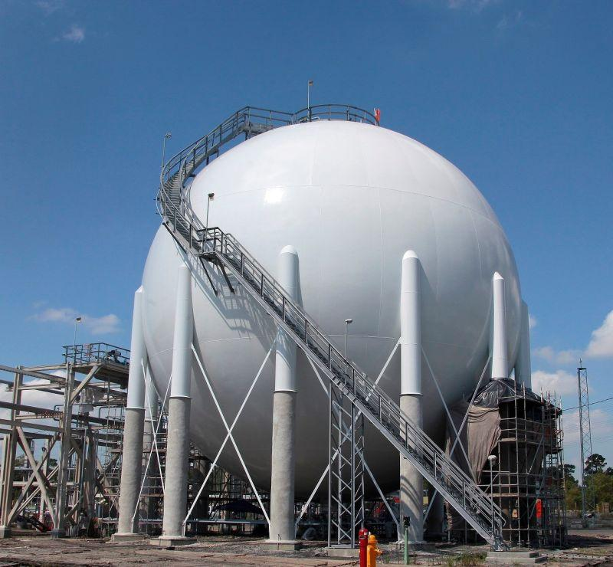
Storage and Containers
Helps estimate material requirements and the volume of portions of spherical vessels.
Mathematics and Geometry
Illustrates the relationship between sphere radius, circular cross-sections, surface area, and volume.

Key Points
# Source: AI Source: Provided by: [Data Path: Persons Table -> ID Column: 1, Name_En Column: Motasem Essam] -> From: [ChatGPT] on [7/25/2026]
- A spherical segment is the solid portion of a sphere between two parallel planes.
- Its bases are circular, and their radii may be equal or unequal.
- The segment height is the perpendicular distance between the cutting planes.
- Its volume depends on the height and both base radii.
- Its curved surface area depends on the sphere radius and segment height.
- Its total surface area includes the curved surface and both circular bases.
- A spherical cap differs from a spherical segment because a cap is bounded by only one cutting plane.

Conclusion
# Source: AI Source: Provided by: [Data Path: Persons Table -> ID Column: 1, Name_En Column: Motasem Essam] -> From: [ChatGPT] on [7/25/2026]
A spherical segment is a portion of a sphere bounded by two parallel planes. It generally has two circular bases connected by a curved spherical surface. Its volume and surface area can be calculated using the segment height, the radii of its bases, and the radius of the original sphere. Spherical segments are useful in geometry, engineering, and the design of curved components.

